MRMv2 RSM Transformations

MRMv2 RSM Transformations 1
What is it? 1
Installing 1
Create Transformation Configuration 2
Executing Transformations 3

What is it?
The MRMv2 Rational Software Modeler (RSM) Transformations consist of two transforms: Rational Requirements Composer (RRC) Template Builder and RequisitePro Schema Updater.
RRC Template Builder: For every Business Component in the MRMv2 Meta Model, the RRC template builder will create templates that can be imported into Rational Requirements Composer. Each template will contain the Business Component Name along with a section for each attribute.
RequisitePro Schema Updater: This transform will update a RequisitePro schema based on the business components in the MRMv2 Meta Model. For every entity of the Meta Model, a new requirement type is created in RequisitePro, and for each attribute of the entity a new attribute is added to the requirement type in RequisitePro. This transform is not a synchronizer (does not delete anything), but will create any new business components or attributes in RequisitePro if not present in a project.

Installing
You should have a zip file, such as ‘misa update site.zip’.
- Within RSM, select “Help > Software Updates…”
- If you have previously followed these steps and have put the new installation file to the exact same location (and filename) as the previous one, then you can skip these sub-steps.
  - Click on ‘Add Site…’
  - Press the ‘Archive...’ button.
  - Navigate to and select the installation zip file and then press Open.
  - Then press OK
- In the list of Available Software, you should see the installation file. You should be able to expand it and see ‘MISA Transformations’.
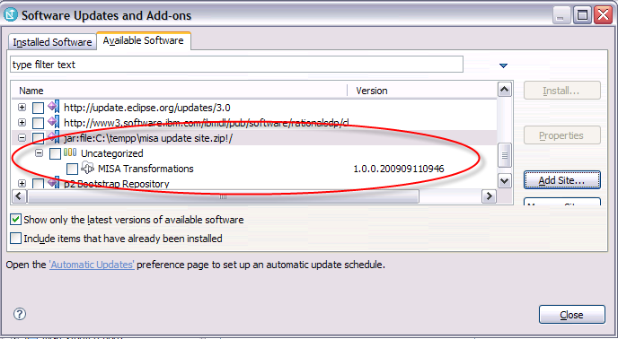
- Select the checkbox next to ‘MISA Transformations’ and then click on “Install…”
- Press the Next button
- Accept the license terms and press the Finish button
- Restart RSM when prompted.

Create Transformation Configuration
Before a transformation can be executed, a transformation configuration needs to be created.
- Within RSM go to Modeling->Transform->New Configuration

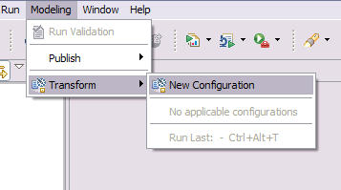

- Specify a name for the configuration (ie. MRMv2Transform) and the destination for the transform (ie. Your modeling project).
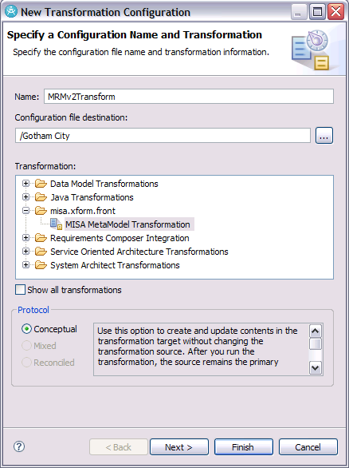
- Click Next
- Next, select the source and target for the transformation. Select your MRM meta model as the source and target.
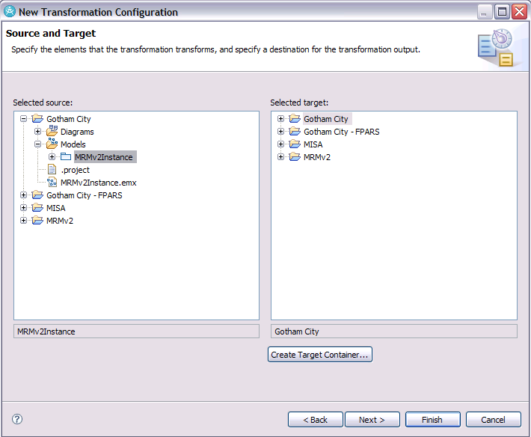
- Click Next
- Provide the transformation properties required by the transformation. Firstly, decide which transform this configuration is going to execute. If this configuration to run the RRC template builder then set this property to true. If this configuration is to execute the RequisitePro Updater, set this property to true. The RequisitePro Updater requires additional parameters:
    - ReqPro Project Path – Path to RequisitePro project (.rqs file).
    - ReqPro Properties File Path – Path to properties file containing all MRM meta model component codes (BusinessComponentCodes.properties).
    - ReqPro User Name – Valid RequisitePro user name
    - ReqPro Password – Valid password for the user name
It is ok to have the configuration run both the RRC template builder and RequistePro Updater. Alternatively, one could create a separate configuration for each.
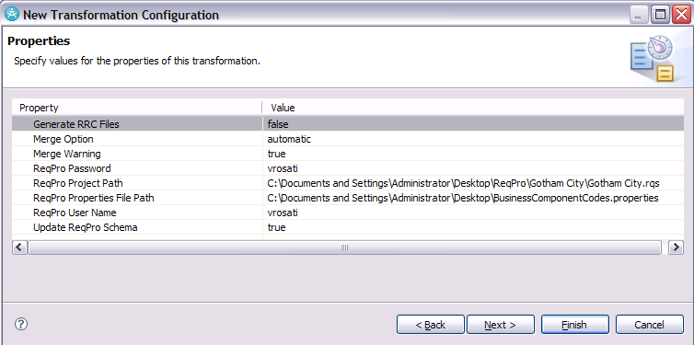
- Click Next
- Click Next on the Auxillary Transformations Sources and Targets
- Click Finish

Executing Transformations
Once the configuration is created, executing and editing can be done as follows:
- Open the configuration file (file with .tc extension). It may already be open after creation.
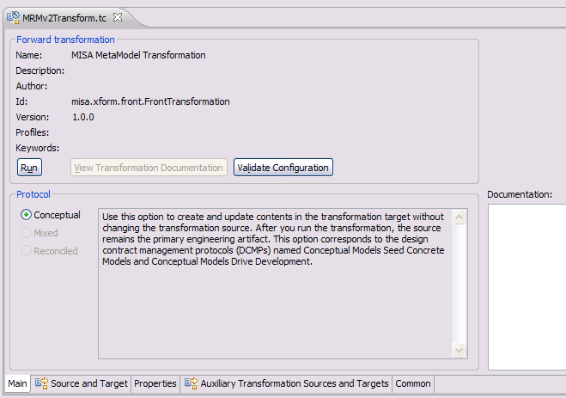
- The Run button will execute the transform(s).
- Each tab contains the information that was setup on the configuration and it can be edited.
- Executing the RRC Template builder will cause a new folder to be created in RSM called Sample Output Folder. It will contain a number of xml files, one for each business component in the source model. These xml files can be imported in RRC as Documents.
- Executing the RequisitePro Updater will have no effect on RSM. Verify the modifications in RequisitePro. (Note: RequisitePro Updater may cause RSM to hang. This does not affect the outcome as RequisitePro does update accordingly. Simply terminate RSM if hanging)

